Name : Krishna Ramani | Student ID : n01657309
Date: 21-04-2026 | Professor Signature:

Lab 9– MIPS Architecture Design – CPU Code Execution

The purpose of this lab is to finish the CPU instruction functions required by the MIPS simulator we build in the last lab.
Procedures
- Hint: Starting from lab 7, the code will be more and more complicated. As a result, you should consider having a consistent development environment and backup your code more frequently.
- Study the MIPS instruction set definition based on the course materials and lecture notes. Follow the examples your professor gives you during the class time, make sure you understand the 32-bit instruction set structure and how to translate the assembly code into its 32-bit machine code.
- Now try to understand the code, and finish the following functions in lab8_9.c:
CPU_Execution(unsigned char opcode, unsigned int machineCode, char *mem)
- Uncomment the following statement in lab8_9.c, so that function CPU_Execution will be included into the project.
// CPU_Execution(opcode, machineCode, mem);

Please follow the following submission requirements for this lab:
- Must demo your code to the professor to get the signature from the professor. (50%)
- Submit the screenshots of the running results and the final memory dump of Data section, and all the register contents. Screenshots must have time/date of the local computer. (30%)
- The lab report is due on the blackboard.
- Answer this question in the text with your submission: (20%)
  - Please briefly describe the function of the code MIPS.asm.
Function of MIPS.asm code:

The MIPS.asm program switches the data in two memory arrays. First, it sets up by loading the starting point of each array and the number of bytes that need to be changed. Then it goes into a loop. Each time it goes through the loop, it reads one value from the first array and one value from the second array. It uses registers as temporary storage to switch the values and then writes them back into the other arrays. The loop keeps going until it has worked through all 32 bytes. The code is just showing how MIPS uses a loop, memory load/store instructions, and registers to move and switch data in memory.

OUTPUT:

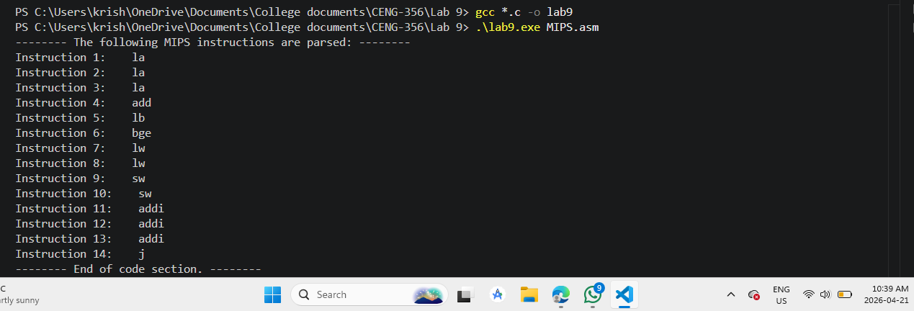

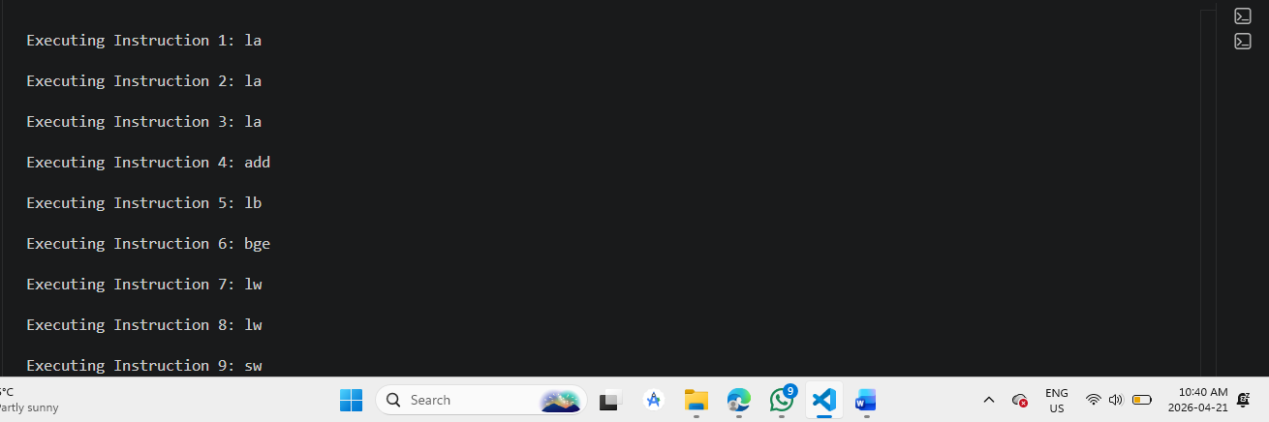

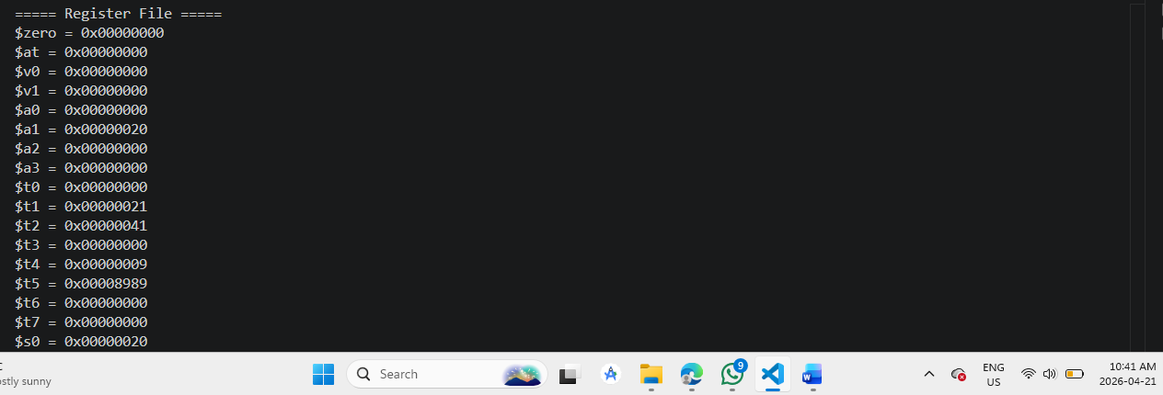

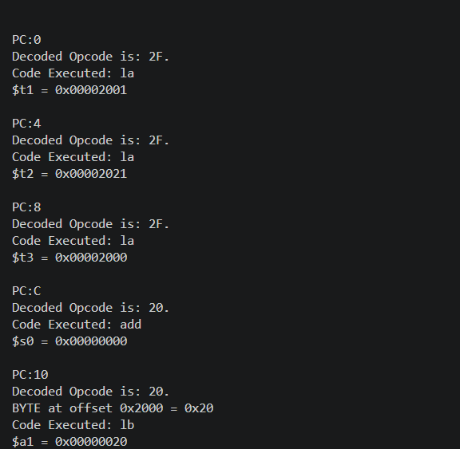
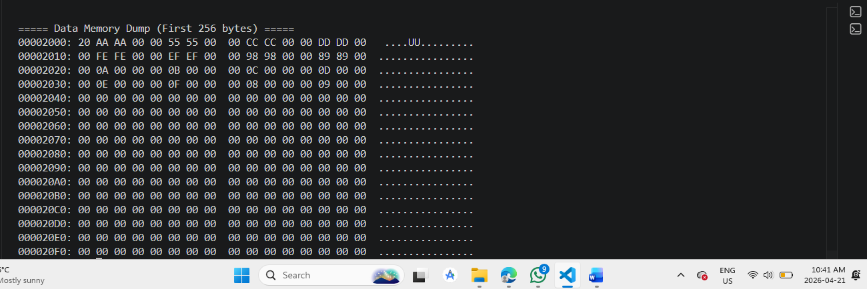

In this lab I didn’t submit previous lab output just added lab 9 output ss.

